Hors d’oeuvres Menu

2026 Minimum Order by Pieces Price

Breaded Chicken Breast Strips 50 80.00
Breaded Mushrooms 50 55.00
Chicken Wings 50 65.00
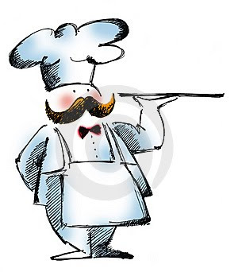
Jumbo tail-on Shrimp 75 Market Price
Spring Egg Rolls 48 60.00
Sauerkraut Balls 50 55.00
Stuffed Jalapeño Poppers 35 50.00
Stuffed Mushrooms 50 65.00
Stuffed Potato Skins 25 60.00
Sweet n’ Sour Meatballs 50 45.00
Shrimp Tempura 50 Market Price

Minimum Order by Guests
Seasonal Fresh Fruit 25 75.00
w/fruit dip
Spinach Spread 25 55.00
(served w/dark pumpernickel round) 25 add’l 10.00
Pineapple Cheese Spread 25 45.00
w/ Crackers
Ham Spread w/Crackers 25 45.00
Crab Salad w/ Crackers 25 65.00
Cubed Cheese w/ Crackers 25 80.00
Fresh Vegetable Tray w/ Dip 25 75.00

Order enough for at least 6 Hors d’ oeuvres per person
Ask about our Chef’s Choice Hors d’oeuvres! .................................................$16.95 per person
(Chef Chooses 4 cold, 2 hot Hors d’oeuvres served during Cocktail Hour)
Chef’s choice can be used only when ordering a meal.

Prices are subject to change depending on market availability
Consuming raw or undercooked meats, poultry, seafood, shellfish, or eggs may increase your risk of foodborne illness
www.germans-villa.com bridalinfohorsdnewrev1/2/26

